Hi, Copilot, I am working on my compsci project, and I am trying to write my code, but I don't know where to start. I have it all laid out, but I don't know how to make the user interface. Here is an image of the pages and the order that I want them in. Can you give me basic code for a page that has buttons like this that I can edit to work for each of my pages? I will be using Drafter to make my code.
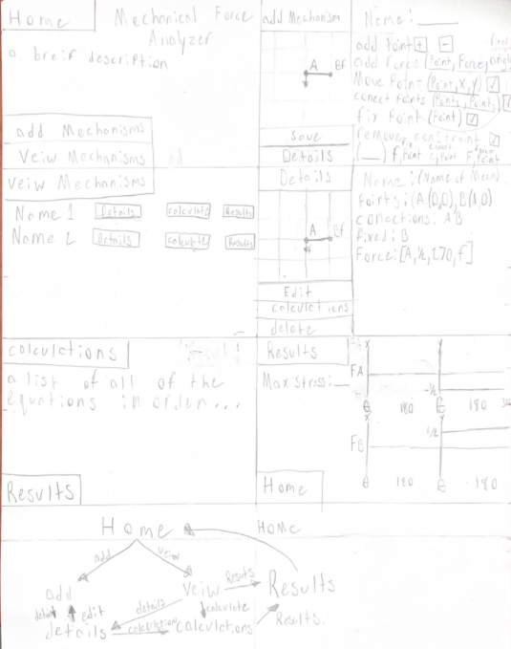

Copilot
I can see your page flow and rough UI sketch here: 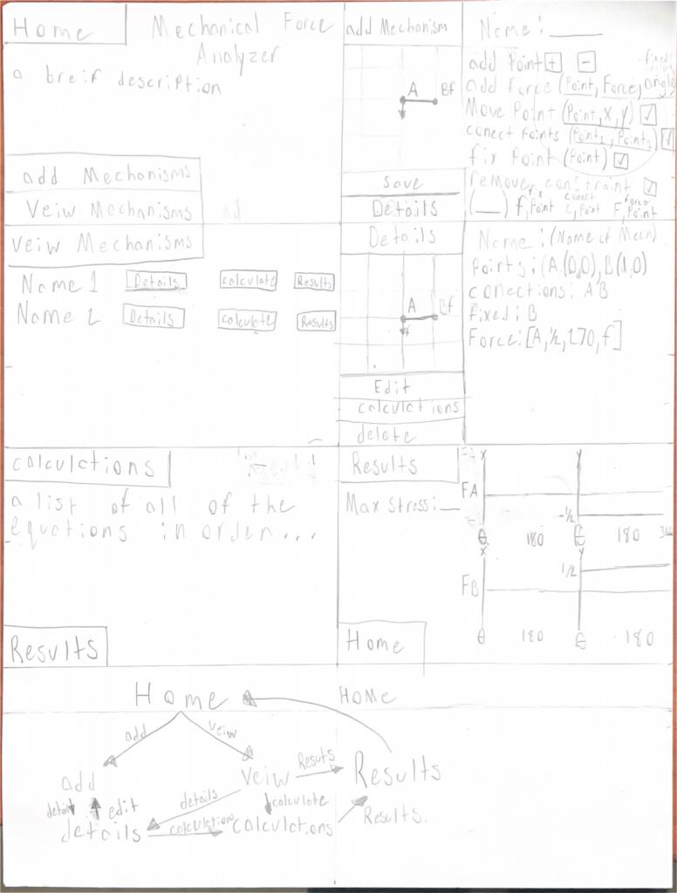
Since you're using Drafter (the Python web framework), the easiest way to build this is to make a separate function for each page and use buttons that link between them.
Here's a simple template you can reuse for every screen:
from drafter import *
@route
def home():
return Page(
"Mechanical Force Analyzer",
Button("Add Mechanism", add_mechanism),
Button("View Mechanisms", view_mechanisms)
)
@route
def add_mechanism():
return Page(
"Add Mechanism",
"Name:",
TextBox("name"),
Button("Save", home),
Button("Details", mechanism_details)
)
@route
def mechanism_details():
return Page(
"Mechanism Details",
"Points:",
"Connections:",
"Forces:",
Button("Back", add_mechanism),
Button("Home", home)
)
@route
def view_mechanisms():
return Page(
"View Mechanisms",
Button("Mechanism 1 Details", mechanism_details),
Button("Mechanism 1 Calculate", calculations),
Button("Mechanism 1 Results", results),
Button("Home", home)
)
@route
def calculations():
return Page(
"Calculations",
"All equations will appear here.",
Button("Results", results),
Button("Home", home)
)
@route
def results():
return Page(
"Results",
"Maximum Stress:",
"Reaction Forces:",
Button("Home", home)
)
start_server(home)

Organization I would recommend
Based on your drawing:
Home
│
├── Add Mechanism
│ ├── Details
│ └── Save
│
├── View Mechanisms
│ ├── Details
│ │ ├── Edit
│ │ └── Calculations
│ │ └── Results
│ └── Results
│
└── Results

Reusable Page Template
Once you get one page working, you can copy this skeleton:
@route
def page_name():
return Page(
"Title",
# Content goes here
Button("Back", previous_page),
Button("Home", home)
)

Example for your "Add Point" screen
@route
def add_point():
return Page(
"Add Point",
"Point Name:",
TextBox("point_name"),
"X Coordinate:",
TextBox("x"),
"Y Coordinate:",
TextBox("y"),
Button("Save Point", add_mechanism),
Button("Back", add_mechanism)
)
One suggestion: before building the calculations, get all the navigation pages working first. Make every button move to the correct page, then go back and add the data entry, calculations, and graphs. That's usually much easier than trying to do everything at once.

